Amazon AWS Spot Price Instance Project: Exploratory Analysis to find cheaper and stable spot instances in the AWS cluster
Topics in Big Data Final Project Submission

Arjun N Mayur
Avisek Naug
Venkataramana Nagarajan

I. INTRODUCTION

Individuals and organizations are constantly faced with the problem of needing to find a cost-effective way to handle an increased computing workload. AWS spot instances provide a solution to this problem by allowing users to purchase spare server capacity for much cheaper than AWS on-demand spot instances. AWS spot instances are obtained by users bidding on spot instances, and if a user’s bid price is higher than the market spot instance price they will obtain a running AWS spot instance. However, once the market spot instance price exceeds or equals the user’s bid price the user’s spot instance will be terminated. Therefore, AWS spot instances are only a good solution for computational work that can be interrupted. Some fields in which AWS Spot instances are commonly used include Big Data and Analytics, Media encoding and image processing, and Scientific Research. Amazon provides historical data related to spot instance prices for free. It would be advantageous for a user to use this data and bid on AWS spot instances in regions where there is less fluctuation in the spot instance price. Our final project involves using Kaggle data sets which have historical data on spot instance prices for different regions. The Kaggle data sets were analyzed using Big Data techniques to find out which regions are best for users to bid on spot instances.

II. DATA DESCRIPTION

The AWS Spot Pricing Market data taken from Kaggle includes data from eleven different regions which were ap-northeast-1, ap-northeast-2, ap-south-1, ap-southeast-1, ap-southeast-2, ca-central-1, eu-central-1, eu-west-1, sa-east-1, us-east-1, us-west-1. For each region the data is separated into five columns, a time stamp (e.g. 2017-04-22 23:53:10+00:00), an instance type (e.g. c4.xlarge), an operating system (e.g. Windows), a region, and a spot price (e.g 1.6503). The data available on Kaggle was collected by using the AWS CLI and was formatted in order to make the data easier to analyze. Then we took the Kaggle data and again formatted the data to have the column headers of Time, InstanceType, OS, Region, and SpotPrice.

III. QUESTION 1: Which region/AZ is historically cheapest for a given type of instance?

The code written to find a solution to question 1 will be explained step by step.
#Import the necesary Modules
import pandas as pd
import matplotlib.pyplot as plt
import matplotlib
%matplotlib inline
matplotlib.rcParams['figure.figsize'] = [15.0,15.0]
First we read all the data for the different regions from their respective csv files. We categorized the data into 1. Asia Pacific, 2. Central, North and South, 3. Europe.

Then we got an array of all the different unique instance types for the region. For this example we got an array of the instance types for the Asia Pacific region south1.
#Get the array of unique names of instances in the data
print(south1.InstanceType.unique())

The output is
['c4.8xlarge' 'm4.xlarge' 'm4.large' 'm4.2xlarge' 'c4.xlarge' 'r3.8xlarge'
'm4.4xlarge' 'r3.xlarge' 'r3.4xlarge' 'c4.4xlarge' 'm4.16xlarge'
'c4.large' 'r3.2xlarge' 'r4.large' 'c4.2xlarge' 'r3.large' 'd2.4xlarge'
'x1.16xlarge' 'i2.xlarge' 'r4.2xlarge' 'x1.32xlarge' 'i3.8xlarge'
'r4.8xlarge' 'd2.2xlarge' 'r4.xlarge' 'i2.4xlarge' 'r4.4xlarge'
'i2.2xlarge' 'i2.8xlarge' 'r4.16xlarge' 'd2.xlarge' 'm4.10xlarge'
'd2.8xlarge' 'i3.4xlarge' 'i3.xlarge' 'i3.large' 'i3.2xlarge'
'i3.16xlarge']

#Read the data from the csv files of Asia Pacific
northeast1 = pd.read_csv("ap-northeast-1.csv")
northeast2 = pd.read_csv("ap-northeast-2.csv")
south1 = pd.read_csv("ap-south-1.csv")
southeast1 = pd.read_csv("ap-southeast-1.csv")
southeast2 = pd.read_csv("ap-southeast-2.csv")
#Read the data from the csv files of Central, North and South America
cacentral1 = pd.read_csv("ca-central-1.csv")
saeast1 = pd.read_csv("sa-east-1.csv")
useast1 = pd.read_csv("us-east-1.csv")
uswest1 = pd.read_csv("us-west-1.csv")
#Read the data from the csv files of Europe
eucentral1 = pd.read_csv("eu-central-1.csv")
euwest1 = pd.read_csv("eu-west-1.csv")

Next we set the instance type. We changed the instance type every time to obtain a new plot.
#Need to do a basic time plot to see variation of prices
#by region for a particular type of instance
instanceType = 'm4.xlarge'

Then we pre-processed all the data so only the instance type we set would be plotted. We used the pandas library to convert the timestamp given by Kaggle to an appropriate date/time that could be plotted.
#Preprocessing for Asia Pacific
df1 = northeast1[northeast1.InstanceType==instanceType]
df1 = df1.set_index(pd.to_datetime(df1['Time']))
df2 = northeast2[northeast2.InstanceType==instanceType]
df2 = df2.set_index(pd.to_datetime(df2['Time']))
df3 = south1[south1.InstanceType==instanceType]
df3 = df3.set_index(pd.to_datetime(df3['Time']))
df4 = southeast1[southeast1.InstanceType==instanceType]
df4 = df4.set_index(pd.to_datetime(df4['Time']))
df5 = southeast2[southeast2.InstanceType==instanceType]
df5 = df5.set_index(pd.to_datetime(df5['Time']))

#Pre processing for Central, North and South America
df6 = cacentral1[cacentral1.InstanceType==instanceType]
df6 = df6.set_index(pd.to_datetime(df6['Time']))
df9 = saeast1[saeast1.InstanceType==instanceType]
df9 = df9.set_index(pd.to_datetime(df9['Time']))
df10 = useast1[useast1.InstanceType==instanceType]
df10 = df10.set_index(pd.to_datetime(df10['Time']))
df11 = uswest1[uswest1.InstanceType==instanceType]
df11 = df11.set_index(pd.to_datetime(df11['Time']))

#Pre processing for Europe
df7 = eucentral1[eucentral1.InstanceType==instanceType]
df7 = df7.set_index(pd.to_datetime(df7['Time']))
df8 = euwest1[euwest1.InstanceType==instanceType]
df8 = df8.set_index(pd.to_datetime(df8['Time']))

The plot for the instance type m4.xlarge is shown below. As you can see the region that has the cheapest spot price is ap-south-1.

#Add prices from Asia Pacific to the Plot
plt.plot(df1["SpotPrice"],'m+',label=instanceType+' in region ap-northeast-1')
plt.plot(df2["SpotPrice"],'r*',label=instanceType+' in region ap-northeast-2')
plt.plot(df3["SpotPrice"],'kD',label=instanceType+' in region ap-south-1')
plt.plot(df4["SpotPrice"],'bd',label=instanceType+' in region ap-southeast-1')
plt.plot(df5["SpotPrice"],'g+',label=instanceType+' in region ap-southeast-2')
#Generate the time plot
plt.ylabel('Spot price')
plt.xlabel('Day of the year')
plt.title('Variation of spot price for instance for different times of the year for instance {}'.format(instanceType))
plt.legend()
plt.show()

Lastly, we plotted the data with the Date of the year on the x-axis and the Spot Price on the y-axis. A plot was created for each instance type and the different regions it could be bid on.

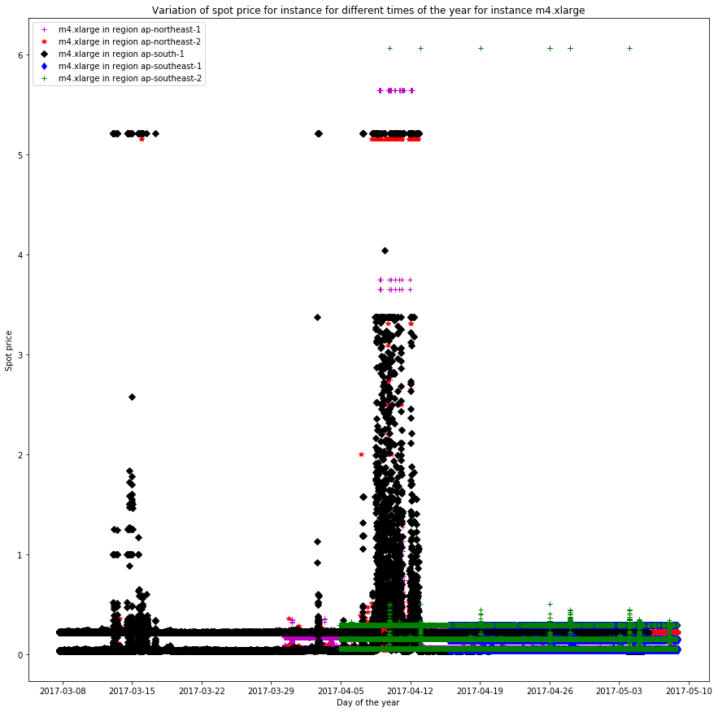

IV. Which region/AZ is historically most stable for a given type of instance?
To figure out which region is historically most stable for a given type of instance, we group data of different regions by standard deviation for each hour of the day. The instance we considered is c4.8xlarge.
The metric used is std.

We use the following block of code to group the data by standard deviation for every hour.

metric = 'std'#'std''mean'
r1 = df1.groupby(df1.index.hour).agg({'SpotPrice':[metric]})
r2 = df2.groupby(df2.index.hour).agg({'SpotPrice':[metric]})
r3 = df3.groupby(df3.index.hour).agg({'SpotPrice':[metric]})
r4 = df4.groupby(df4.index.hour).agg({'SpotPrice':[metric]})
r5 = df5.groupby(df5.index.hour).agg({'SpotPrice':[metric]})
r6 = df6.groupby(df6.index.hour).agg({'SpotPrice':[metric]})
r7 = df7.groupby(df7.index.hour).agg({'SpotPrice':[metric]})
r8 = df8.groupby(df8.index.hour).agg({'SpotPrice':[metric]})
r9 = df9.groupby(df9.index.hour).agg({'SpotPrice':[metric]})
r10 = df10.groupby(df10.index.hour).agg({'SpotPrice':[metric]})
r11 = df11.groupby(df11.index.hour).agg({'SpotPrice':[metric]})

We used the following block of code to plot the graph:
%matplotlib inline
matplotlib.rcParams['figure.figsize'] = [15.0,15.0]
plt.plot(range(1,25),r1,'r+-',label=instanceType+' in region ap-northeast-1')
plt.plot(range(1,25),r2,'ko-',label=instanceType+' in region ap-northeast-2')
plt.plot(range(1,25),r3,'gv-',label=instanceType+' in region ap-south-1')
plt.plot(range(1,25),r4,'b^-',label=instanceType+' in region ap-southeast-1')
plt.plot(range(1,25),r5,'cx-',label=instanceType+' in region ap-southeast-2')
plt.plot(range(1,25),r6,'y*-',label=instanceType+' in region ca-central-1')
plt.plot(range(1,25),r7,'m4-',label=instanceType+' in region eu-central-1')
plt.plot(range(1,25),r8,'bD-',label=instanceType+' in region eu-west-1')
plt.plot(range(1,25),r9,'md-',label=instanceType+' in region sa-east-1')
plt.plot(range(1,25),r10,'kD-',label=instanceType+' in region us-east-1')
plt.plot(range(1,25),r11,'rs-',label=instanceType+' in region us-east-2')

plt.xlabel('Hour of the day')
plt.ylabel(metric+ 'for Spot Price for the Instance'+instanceType)
plt.title(metric+' value of the spot price for the instance '+instanceType+' by the hour for different regions')
plt.legend()
plt.show()
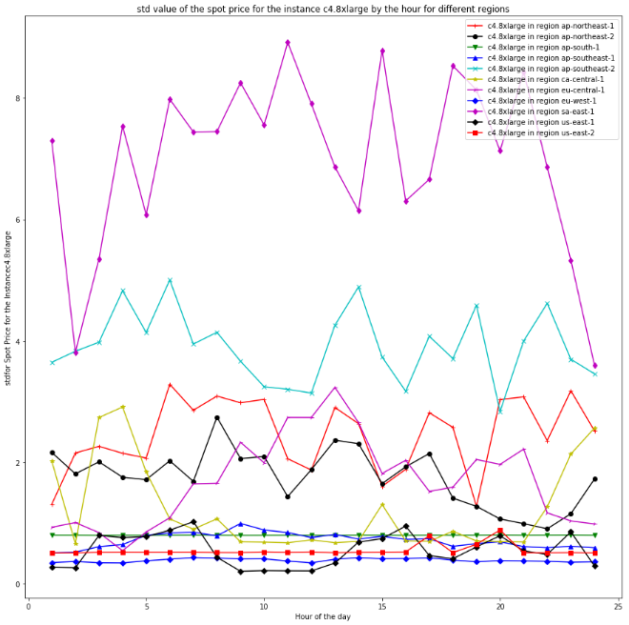
After plotting the obtained data, we get the following graph
We can clearly see that historically eu-west-1 is the most stable for most of the time as the plot line remains low for most of the time as compared to others. But if we consider a time interval between 9am and 12 pm, us-east1 is more stable just for that time period.

V. Which regions are likely to stay under a certain spot price, which would allow you to determine with some amount of certainty whether a SPOT instance will stay up for the next 6, 12 or 18 hours.
In order to see, which region has the SPOT price under certain threshold, so that we do not lose the instance for at least 6 to 8 hours, we need to look at different regions and the maximum value of the SPOT price at different time of the day.

Again, we use the following piece of code to group the data by the hour of the day. And here the metric used is max i.e we plot the highest value that a region has for each hour. The region that has the minimum max value for each hour will be a safe choice for a SPOT instance so that we don’t lose it for the next 6,12 or 18 hours.
metric = 'std'
r1 = df1.groupby(df1.index.hour).agg({'SpotPrice':[metric]})
r2 = df2.groupby(df2.index.hour).agg({'SpotPrice':[metric]})
r3 = df3.groupby(df3.index.hour).agg({'SpotPrice':[metric]})
r4 = df4.groupby(df4.index.hour).agg({'SpotPrice':[metric]})
r5 = df5.groupby(df5.index.hour).agg({'SpotPrice':[metric]})
r6 = df6.groupby(df6.index.hour).agg({'SpotPrice':[metric]})
r7 = df7.groupby(df7.index.hour).agg({'SpotPrice':[metric]})
r8 = df8.groupby(df8.index.hour).agg({'SpotPrice':[metric]})
r9 = df9.groupby(df9.index.hour).agg({'SpotPrice':[metric]})
r10 = df10.groupby(df10.index.hour).agg({'SpotPrice':[metric]})
r11 = df11.groupby(df11.index.hour).agg({'SpotPrice':[metric]})
After plotting the obtained data like in the previous example, we get the following graph
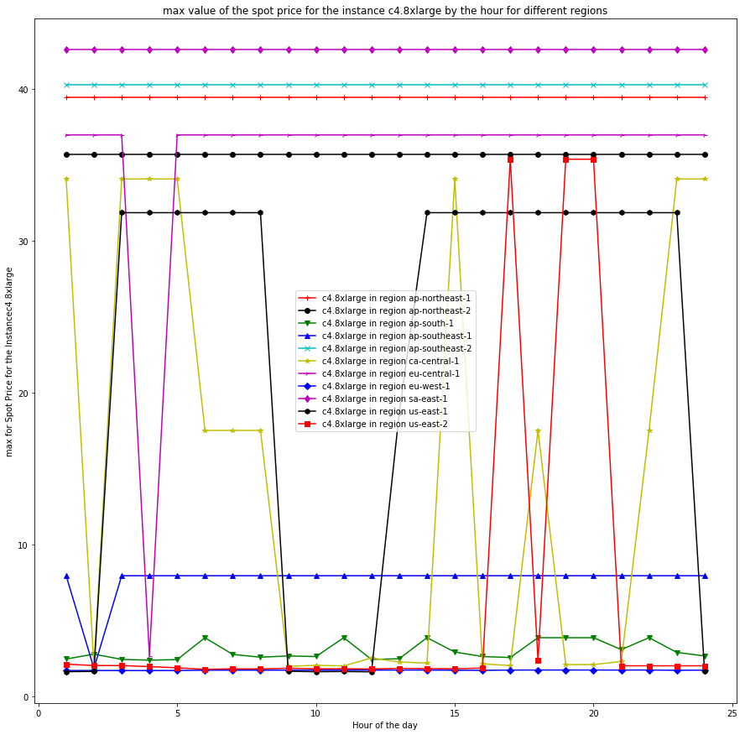
We can clearly see that for c4.8xlarge, the maximum price of spot instance consistently stays below a certain threshold in the regions eu-west-1 and us-east-2(for a certain time period in between 6am to 4pm)

So eu-west-1 and us-east-2 would be the two safe choices.

IV. Cheapest region with lowest spot price change probability in the next 20 minutes
In order to predict the region with the lowest price for a particular type of instance which could maintain that price for next 20 minutes, we had to know a few things.
- The average value of the spot price over a 20 minutes interval from the data.
- The non-normalized probability of increase in spot price in the next 20 minutes given the current spot price.
To solve this problem we took the following steps and the associated results are also discussed in light of the problem.
- The entire data frame is read from each csv file based on the region being Asia Pacific (e.g. ap-southeast, ap-northeast etc.)
#Read the data from the csv files of Asia Pacific
northeast1 = pd.read_csv("ap-northeast-1.csv")
northeast2 = pd.read_csv("ap-northeast-2.csv")
south1 = pd.read_csv("ap-south-1.csv")
southeast1 = pd.read_csv("ap-southeast-1.csv")
southeast2 = pd.read_csv("ap-southeast-2.csv")

- Select the particular instance we are interested in studying
#Need to do a basic time plot to see variation of prices
#by region for a particular type of instance
instanceType = 'm4.10xlarge'

- Next, we select those particular rows of the data that correspond to the “instance” of interest to us. Since Linux is the majority of the OS s in the cluster, we decided analyze the data for the Linux Cluster in this project as it would give us a homogeneous representation of the data.
df1=southeast1[southeast1.InstanceType==instanceType]
#selecting Linux OS for the comparison as most prefer this
df1 = df1[df1.OS=='Linux/UNIX']
- Next we index the data by the date–time variable in the actual AWS data because that data was not properly arranged in terms of the time variables
#Indexing by datatime
df1 = df1.set_index(pd.to_datetime(df1['Time']))
#Sorting the data by time since they are not sorted
df1 = df1.sort_values('Time')
#Removing the irrelevant labels since all of them are same except spot price and time index
df1.drop(labels=['Time','InstanceType','OS','Region'],inplace=True,axis=1)

- In order to see whether price changes in the next twenty minutes we need to create first order differences in the price change and add it to the column of the data frame.
- After that we threshold the data to create areal to binary 0-1 mapping as follows.
If Change in price > 0, then replace change by 1
If Change in price <= 0, then replace change by 0
- This helped us create a 0-1 mapping
- Next we binned the data into contiguous 20 minute intervals and stored a mean value of the Change variable. In this case, the sum would give us a probability of increase in price in the next twenty minutes by virtue of the 0-1 assumption.
'''
Creating a first order difference to find if price has changed between each recorded time point
Later we will group these changes in to 20 minute chunks to see how frequently
price fluctuates or in this case increases
'''
df1["Change"] = df1["SpotPrice"].diff(-1)
#Thresholding so that increase in price is 1 and decrease is 0
mask1 = df1.Change > 0
df1.loc[mask1,'Change'] = 1
mask2 = df1.Change <= 0
df1.loc[mask2,'Change'] = 0
#binning the changing price data into 20min minute intervals and change is now in terms of probability
df1 = df1.resample('20T').mean()#1T=1minute,1H=1hour
#dropping intervals which have no data
df1.dropna(axis=0, how='any',inplace=True)

- Now, since there were several rows in the data which had almost the same spot price, we had to group together spot prices which are relatively close together in to a bin and take the average of the probabilities to make any reasonable inferences.
#Within a 20 minute range when the price is around 'Spot Price', what is the probability of Price Increase ('Change')?
r1 = df1.groupby(df1.SpotPrice).agg({'Change':[metric]})

- Now we did the same procedure for each region and plotted the results.
%matplotlib inline
matplotlib.rcParams['figure.figsize'] = [60.0,15.0]
fig, ax = plt.subplots()
width = 0.8 # the width of the bars
ax.plot(r1[r1.index<=1],'rd--',label='Probability of spot price increase in next 20 min in SE1')
ax.plot(r2[r2.index<=1],'bD--',label='Probability of spot price increase in next 20 min in NE1')
ax.plot(r3[r3.index<=1],'c4--',label='Probability of spot price increase in next 20 min in NE2')
ax.plot(r4[r4.index<=1],'m*--',label='Probability of spot price increase in next 20 min in SE2')
plt.title('Probability of Spot Price Increase in next 20 min at different spot price Values(Non normalized Values)')
plt.xlabel('Spot Price')
plt.ylabel('Probability of Spot Price Increase')
plt.legend()
plt.show()

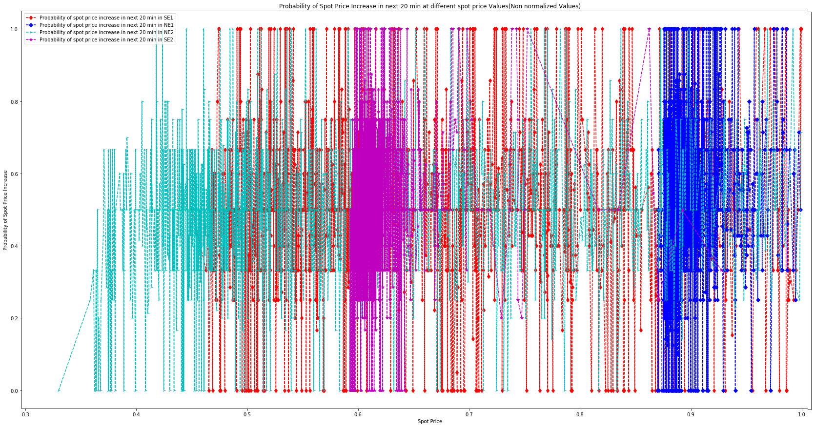
- Now we show the probability of price increase in the next 20 minute interval for different regions in the Asia Pacific for a range of prices. From the graph we can easily infer which region we should buy the spot instances from so that we can get a cheaper price keeping mind the chances that the instance might get terminated with a probability given by the Y-axis corresponding to the spot price at that time given by the X-axis.

